Table of Contents

1. Overview of Project 2

2. User 3

User Login 3

User Dashboard 4

I. Recognize Now 4

II. Recognized You 5

III. Reward Points and Redemptions 6

3. Admin 7

Admin Dashboard 7

I. Overview 7

II. User Management 7

III. Points Management 7

IV. Product Catalog Management 8

V. Reporting and Analytics 8

VI. Email Notifications Configurations 8

# Overview of Project

The Employee Reward and Recognition Portal is a web-based platform designed to foster a culture of appreciation within the organization. It allows employees to recognize their peers for their contributions and behaviors that align with company values, using a predefined set of tags such as “Supportive,” “Technical,” or “Polite.”

Each recognition results in reward points being allocated to the recognized employee. These points can later be redeemed for various products from an internal catalog.

The system not only empowers employees to acknowledge one another but also helps management track recognition trends and engagement across departments.

**Key Features:**

* Employee Recognition: Simple and intuitive interface for recognizing peers.
* Reward Points System: Each recognition action adds reward points to the recipient, which can be redeemed for gifts.
* Product Catalog: A curated list of products that employees can choose from using accumulated points.
* Recognition History: Each user can view recognitions they’ve received and sent.
* Admin Panel: Management and administration capabilities, such as monitoring employee activity, managing products in the catalog, and reviewing points distribution.
* The portal aims to increase engagement, promote teamwork, and boost employee morale, thereby contributing to a positive work environment.

# User

## User Login

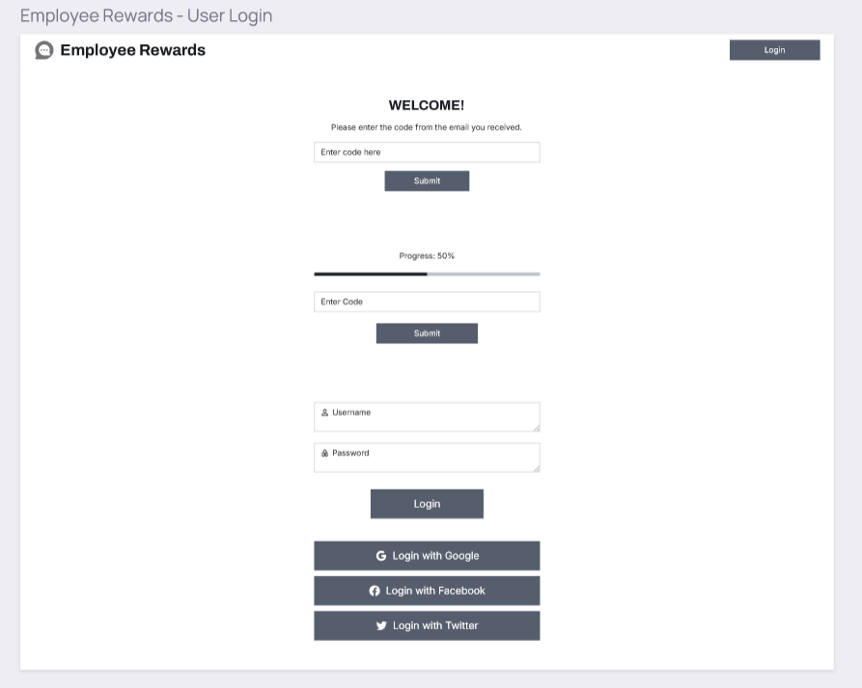

* User will be able to sign in using the credentials; username and Password.
* After successful login it will redirect to the User reward portal.

## User Dashboard

* This is the first screen; the user will be able to view it after login.
* The dashboard screen provides the overview of all sections.
* The Left side listing of the section will provide the accessibility to manage Profiles and Settings.

### Recognize Now

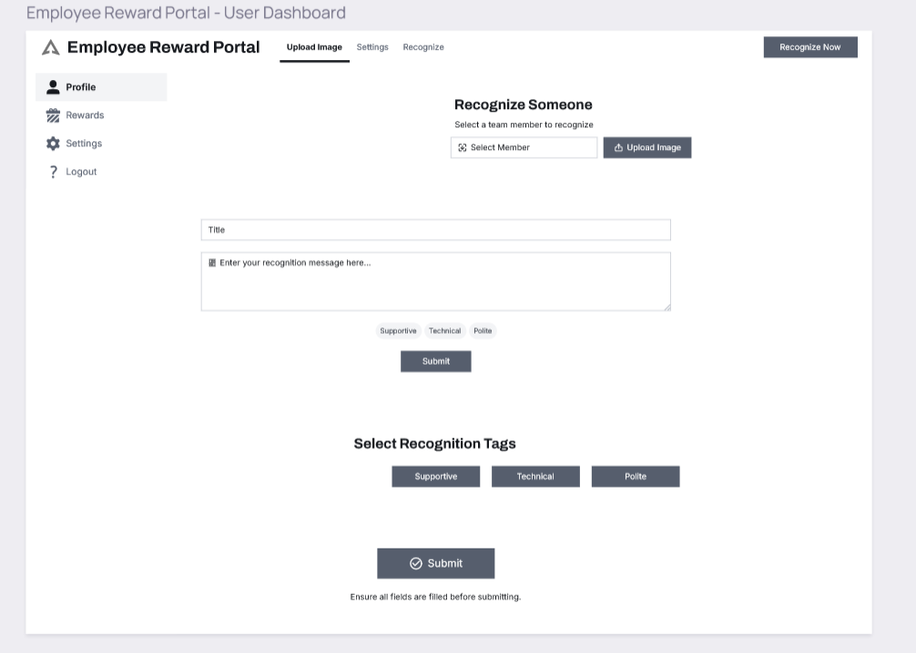

* By clicking the **Recognize** icon the pop-up window will be open to recognize our team member.
* Select Team Member
* Recognize Title and Message
* Select the Predefined tags such as Supportive, Technical, Polite
* Submit the recognition.

### Recognized You

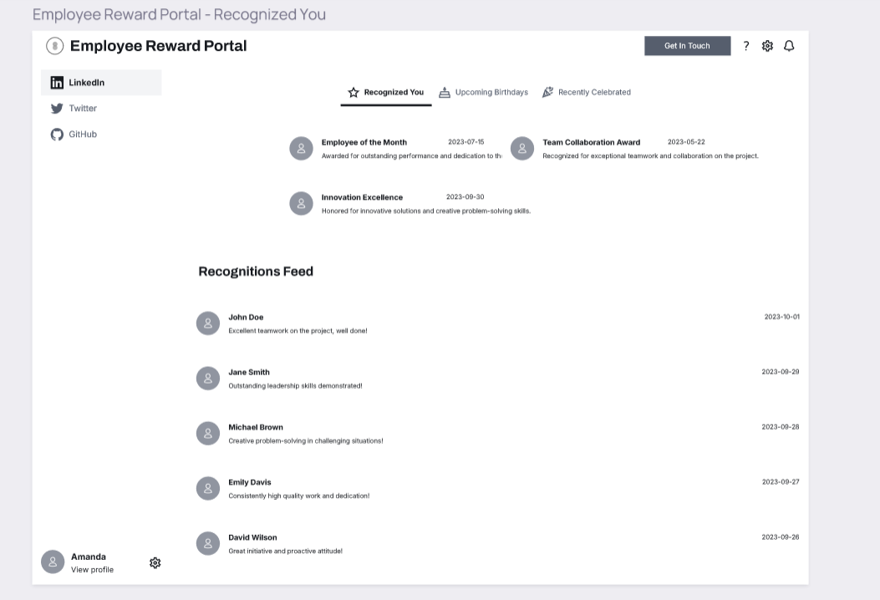

* By clicking the **Recognized you,** theuser will view all the recognition that he received from our team members in the organization.
* User will be able to view details of received recognition; the name of the person, message, and tag category of recognition.

### Reward Points and Redemptions

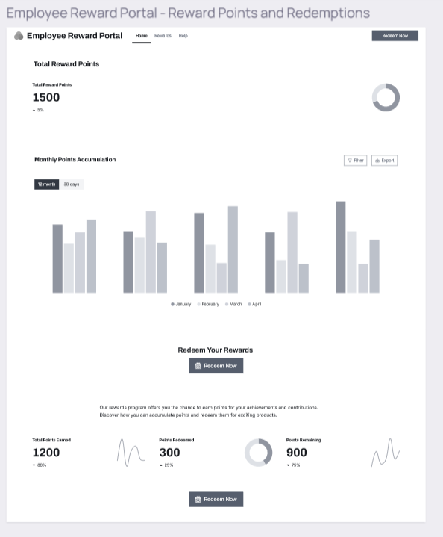

* User will be able to view total reward points and Monthly wise reward point summary.
* User can redeem reward points by clicking the **Redeem Now** icon and it will redirect to the product catalogue page, where the user can select any product to redeem according to reward points.
* Once the user selects a product for redemption, the system will deduct the equivalent point from the user account and the order will be processed successfully.

# Admin

Admin will provide a facility to user to manage recognition, reward points, products, User management, and reporting.

## Admin Dashboard

### Overview

* **Employee Listing** – The admin will be able to view employee profiles, total points, and redemptions. Admin will be able active and de-active employees.
* **Review Recognition** – Admin will be able to view employee recognition and verify that it will be as per company standards and values and also mark the flag inappropriate in case of any error/wrong recognition.
* Total Recognition
* Total points rewarded to employee
* Top recognized employee or team (with percentage graph)
* Redemption request listing; Pending, Approved

### User Management

* **User Roles:** Admin will be able manage role by access level for the Project Manager, Team lead and employee.

### Points Management

* Admin will be able to set the expiry date of rewards (unused points expire in a year) and also can manage any error in reward points.

### Product Catalog Management

* **Add/Remove Products:** Admins can add new products to the catalog or remove old/expired products.
* **Product Categories:** Organize products by categories (e.g., Electronics, Gift Cards, Home Goods).
* **Product Inventory:** Track availability of products to ensure stock for redemptions.
* **Set Point Requirements:** Admins can assign point values to each product based on cost and demand.

### Reporting and Analytics

* **Recognition Trends:** Admins will be able to view the report, which teams are recognizing others and most rewards category tags.
* **Top Performer** – Top recognized Individuals and Team.
* **Redemptions History** – The admin will be able to view, what products and category redeemed mostly.

### Email Notifications Configurations

* Set up email for various notification emails.